# 1. Abstract

This project presents a finite element analysis (FEA) of a regular hexagon structure using Static Structural and Transient Structural simulation techniques. The material properties were derived from the student roll number (ME-1867), resulting in a Young’s Modulus of 67,000 MPa and a Poisson’s Ratio of 0.28.

The static analysis utilized a load of 2,011 N (calculated from the date of birth), while the transient simulation applied a time-dependent load of 280.5 N (based on the USD to PKR exchange rate). One face of the hexagon was fixed, and a remote force was applied at one-third off the face. The analysis compares the deformation and stress results between the static equilibrium and the time-dependent transient response**.**

# 2. Introduction

Finite Element Analysis (FEA) is a numerical method used to predict how a part behaves under physical conditions. In this project, a regular hexagon geometry was analyzed under two distinct conditions:

1. Static Structural: Assumes the load is applied slowly, ignoring inertial and damping effects.
2. Transient Structural: Analyzes the dynamic response of the structure over a defined time period (time-dependent), considering inertia and damping.

The goal is to observe how the hexagon deforms when a remote force is applied at a specific offset location on the fixed face.

# 3. Problem Statement

The objective is to analyze a regular hexagon structure under custom-defined constraints based on personal data.

**3.1 Material Properties (Derived from Roll No.1902)** Young’s Modulus (E):

E = (Last two digits) x 103 = 67 x 1,000 = 67,000 MPa

• Poisson’s Ratio:

ν = 0.28

## 3.2 Loading Conditions

* **Static Load : Calculated from Date of Birth (06-Jan-2004).**

FStatic = 6 + 1 + 2004 = 2,011 N

* **Transient Load: Based on the USD to PKR exchange rate.**

FTransient = 281.5 N

## 3.3 Boundary Conditions

* Support: One face is fully Fixed.
* Load Application: Remote Force applied at 1/3rd distance of the fixed face.
* Time Step (Transient): 0.2 seconds**.**

## 4. Geometry Modeling

The geometry consists of a regular hexagon extruded to a specified thickness. The model was generated using the Design Modeler/Space Claim interface within Ansys.

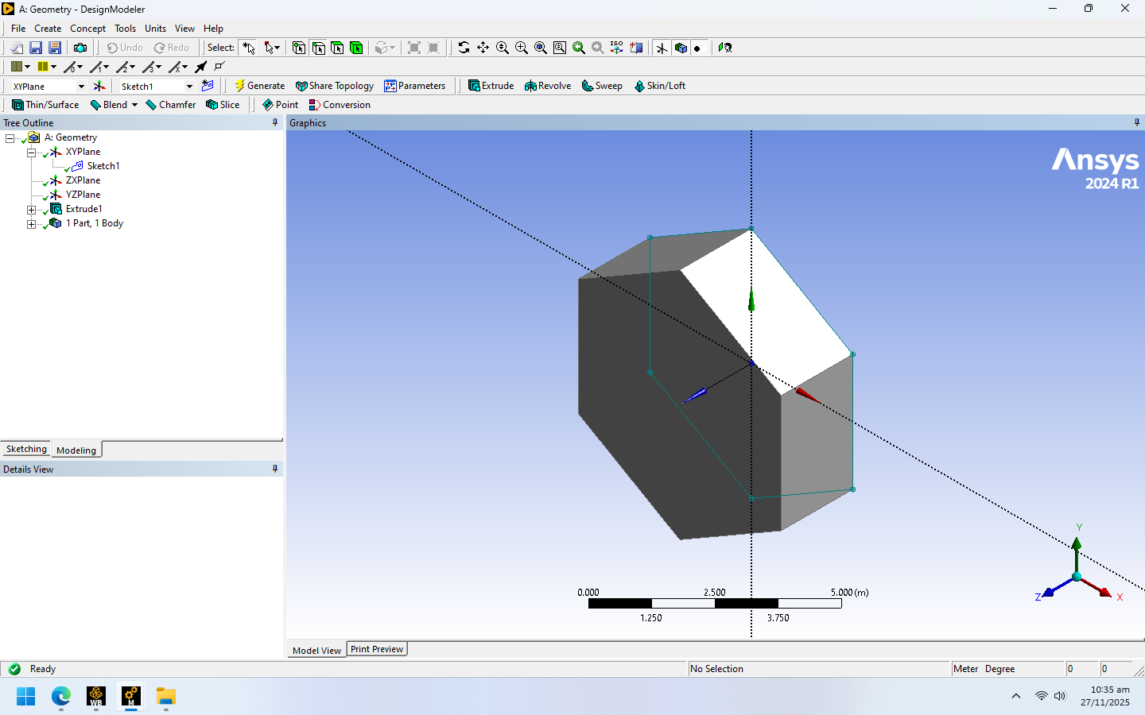

**Figure 1:** 3D Geometry of the extruded hexagon model.

## 5. Material Properties

A custom material named "ME-1867" was defined in Engineering Data with the calculated stiffness values**.**

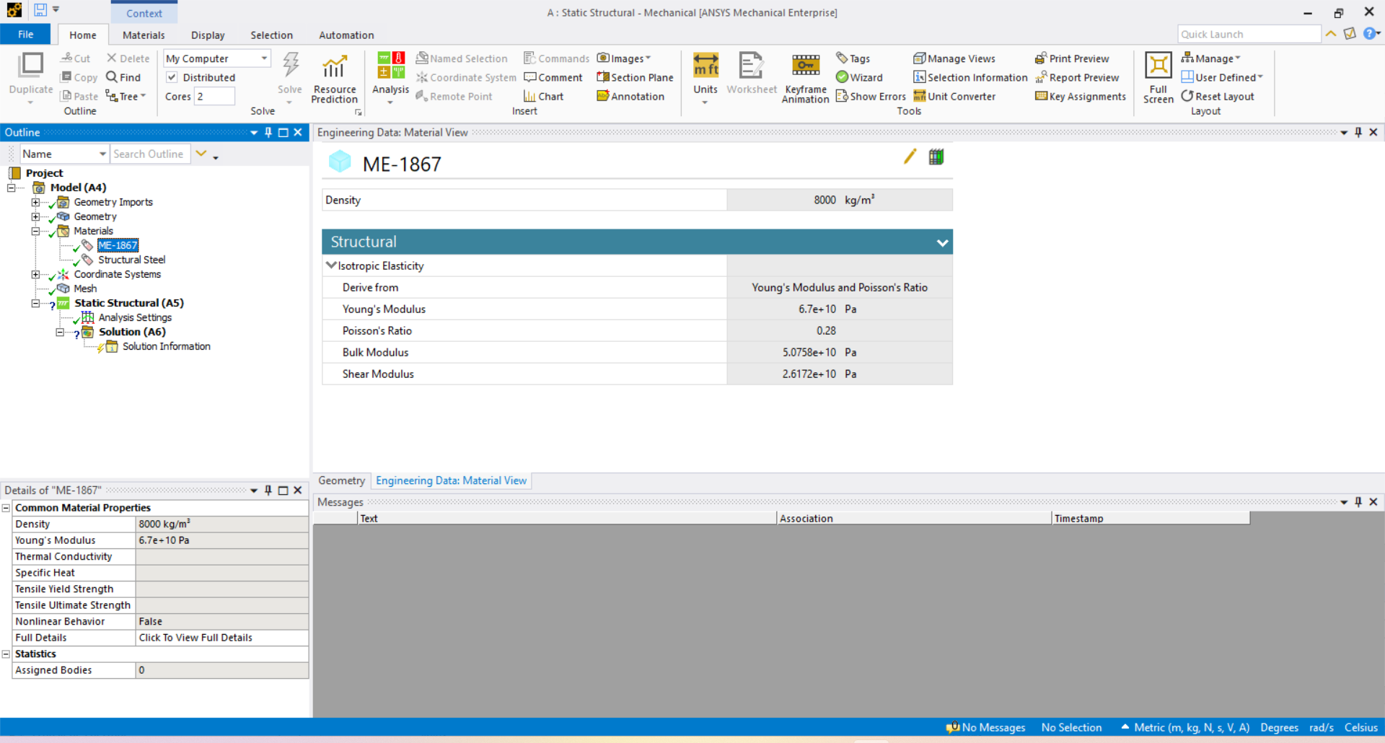

**Figure 2:** Engineering Data showing Young's Modulus of 67,000 MPa.

## 6. Boundary Conditions

To simulate the physical bending and shear, specific constraints were applied:

1. Fixed Support: Applied to one side face of the hexagon.
2. Remote Force: Applied to the same face but offset to 1/3rd of the length. This creates a moment arm, inducing rotation/bending in addition to the linear force.

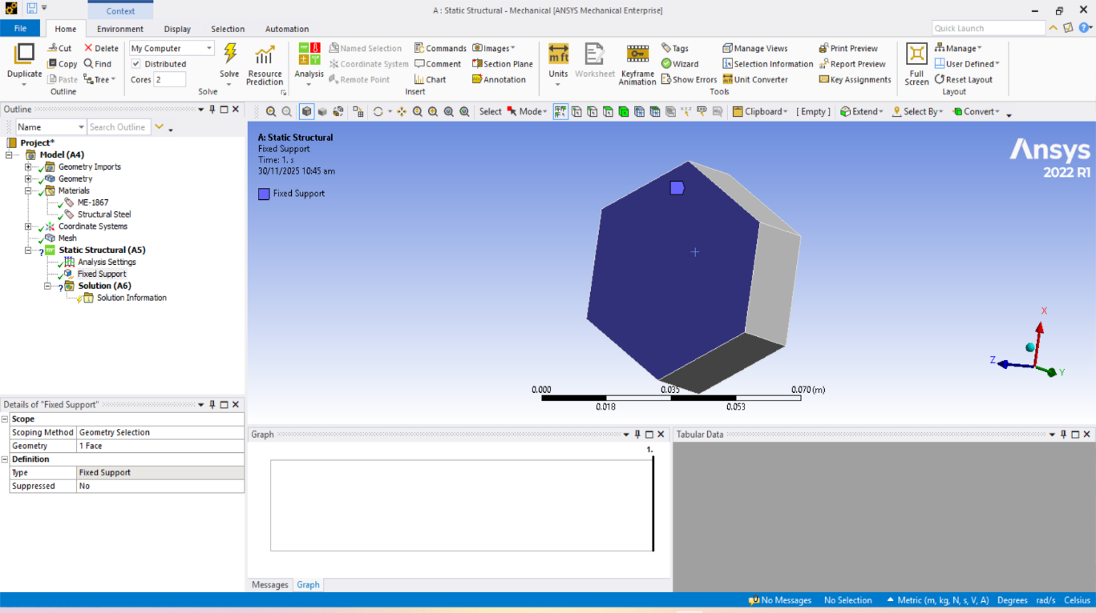

**Figure 3:** Fixed Support applied to the face.

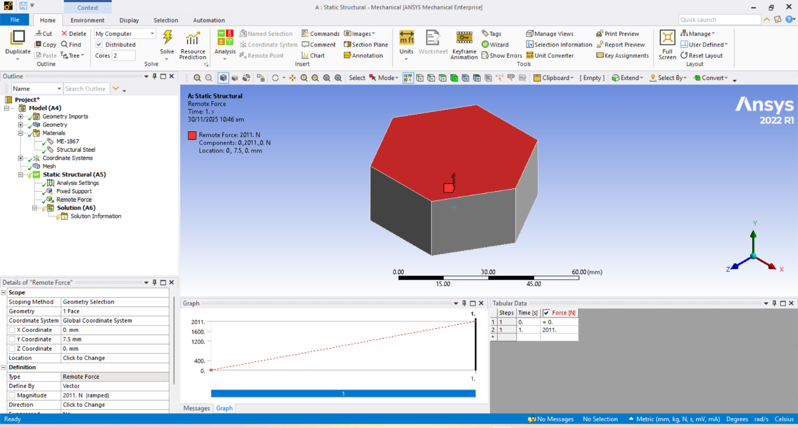

**Figure 4:** Remote Force applied at 1/3rd offset location.

## 7. Meshing & Convergence

A mesh convergence study was conducted to ensure the accuracy of the results. The mesh was refined in three iterations to observe the stability of the Equivalent Stress.

**Figure 5:** Meshed model of the hexagon with element Quality**.**

**Figure 6:** Mesh Convergence Graph (Solution Number vs. Stress).

## 8. Static Structural Simulation

In the static analysis, the load of **2,011 N** was applied. The solver calculated the final equilibrium state.

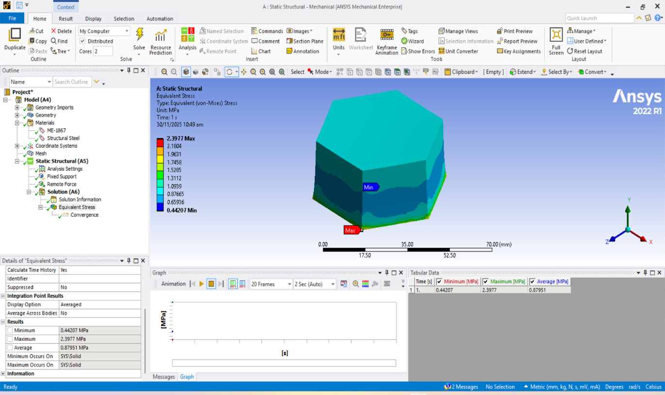

**Figure 8:** Equivalent (von-Mises) Stress (Static).

## Results

The static results show the maximum deflection occurring at the tip of the hexagon opposite the fixed face.

## 9. Transient Structural Simulation

The Transient Structural analysis was performed to determine the time-dependent response. Unlike Explicit Dynamics (used for high-speed impact), Transient Structural is used here for a standard dynamic load over a duration of 1.4 second.

**Simulation Settings:**

* **Load: 281.5 N (USD Rate).**
* **Step End Time: 1.2 s.**
* **Time Step: 0.2**

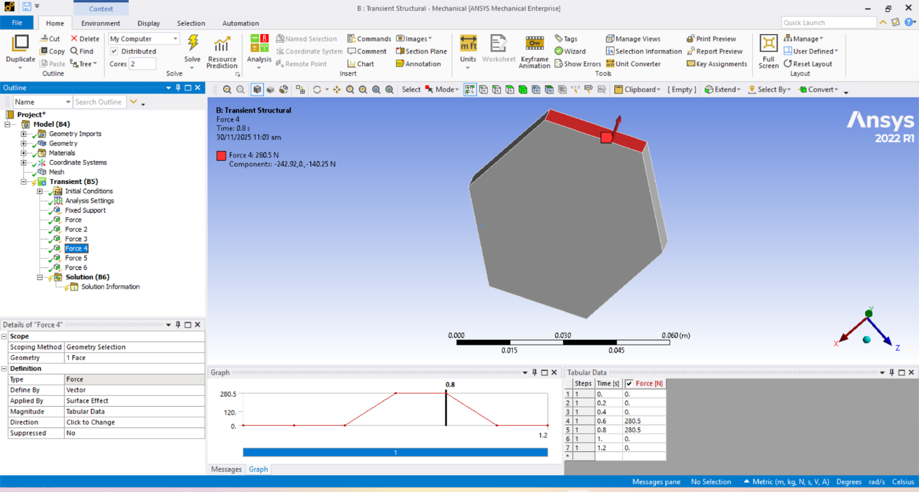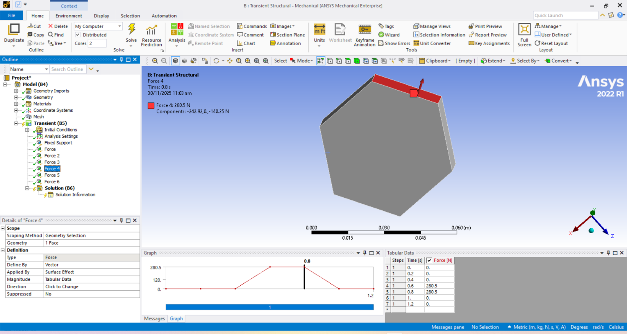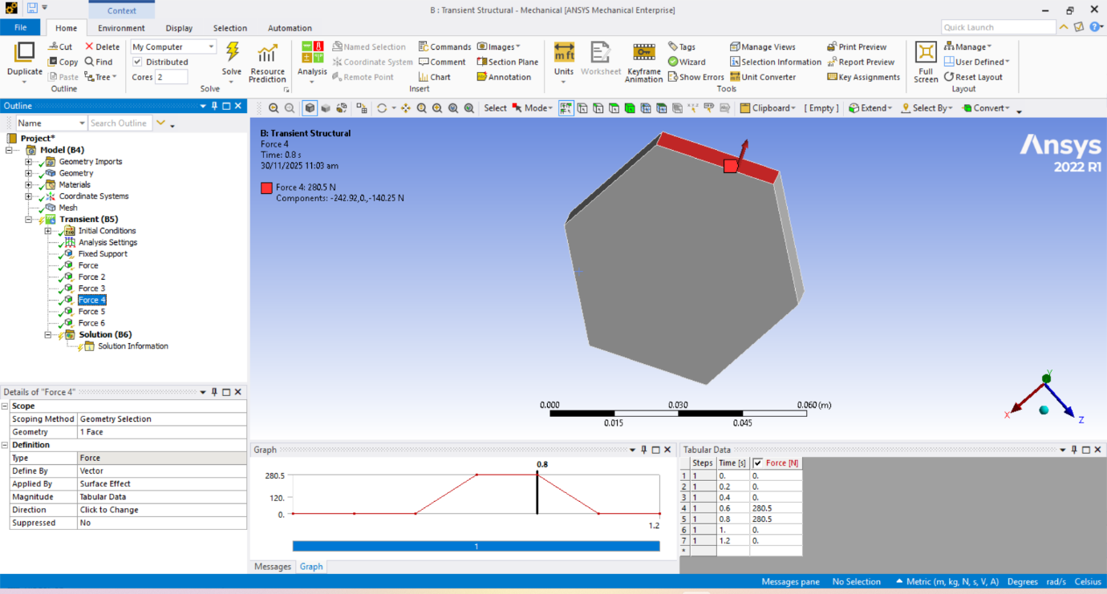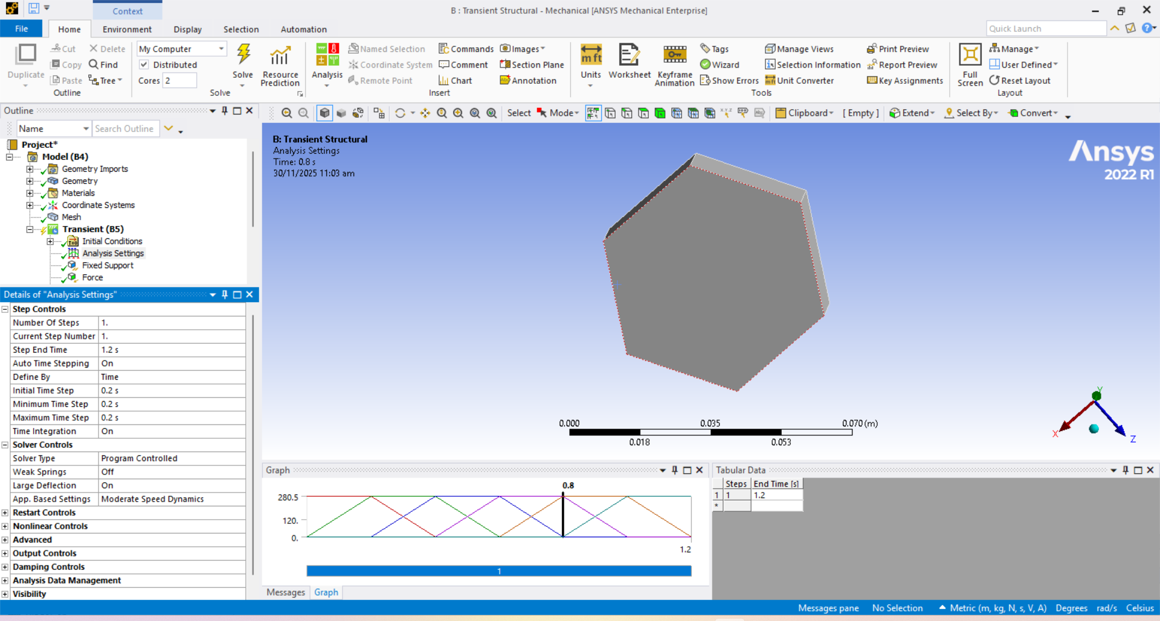

**Figure 9:** Transient setup showing time steps of 0.2s and tabular data of force 4 with graph.

## Boundary Conditions (Transient)

For dynamic behavior, the boundary conditions are demonestrated blow.

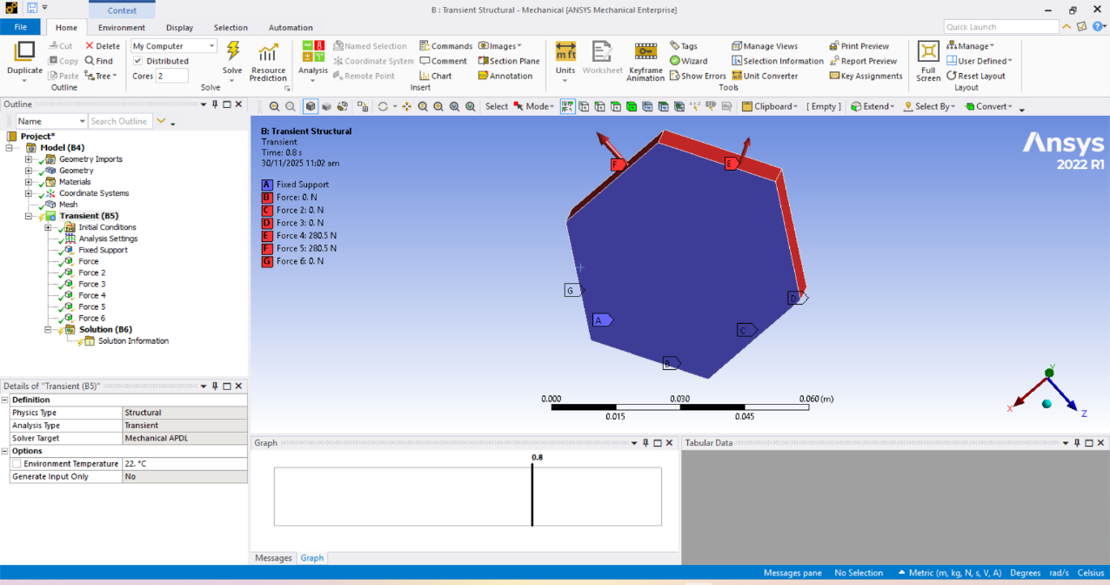

**Figure 10:** Figure 10: Fixed Support(face A) and Forces (B,C,D,E,F,G) applied in the Transient environment***.***

t = 0.4 t =0.6

t = 0.90517 t = 1.0784

## 10. Comparison & Conclusion

|  |  |  |
| --- | --- | --- |
| Parameter | Static Structural | Transient Structural |
| **Load Magnitude** | 2,011 N | 280.5 N |
| **Time Dependency** | None (Equilibrium) | Time-Dependent (0.2s steps) |
| **Deformation Trend** | Higher (due to higher load) | Lower (due to lower load) |

**Table 1:** Comparison of Results

## Conclusion

The project successfully demonstrated the application of FEA on a hexagon model using personal data for boundary conditions. The **Static Structural** analysis provided the maximum stress limits under a heavy load (Date of Birth derived), while the **Transient Structural** simulation visualized the system's behavior under a lighter, time-stepped load (USD Rate derived). The use of a **Remote Force at 1/3rd distance** introduced realistic moment effects on the fixed face.